**Overview about Machine Learning (ISL chapter 1,10):**

Statistical learning, is the whole set of tools, helps in understanding data. These tools can be categorized to supervised, and unsupervised. Supervised statistical learning, uses given data (inputs), and predict, estimate their output, this method is broadly used. However, this project will primarily focus on supervised statistical learning, which is recognised as having variety of inputs, without having their corresponding supervised outputs.

Through unsupervised learning, by inspecting each element characteristics, we can reach the capacity of grouping similar data, within a certain dataset, to the same cluster(group). Its primary goal, is to discover significant aspects about the measurements. Principle Components Analysis, a type of unsupervised learning, is a useful tool for visualising data, or pre-processing. Moreover, Clustering, is another valuable technique, that simplifies the process of determining subgroups in dataset.

* Unsupervised Statistical Learning Tools:
  + Principal Components Analysis (PCA):

PCA Is a largely known technique, that’s used for reducing dimensionality, and decomposing a large dataset, that has a huge number of dimensions (to a lower dimensional space). The data points will be displayed, as orthogonal components, which describes the maximum amount of the variance. In general, instead of using all parameters of a dataset, using PCA will result in using, for example, 2 values at most that will eventually provide a precise representation of data.

Some of the benefits of using PCA can be summarised in few points,

* + - it clearly decreases the requirement of capacity and memory used.
    - Decrease complexity of system.
    - less sensitive to noise than other algorithms.

However, it can be argued that, evaluation of the covariance matrix result in less accuracy. Which can be viewed as a disadvantage of PCA. <https://file.scirp.org/pdf/JSIP_2013101711003963.pdf>

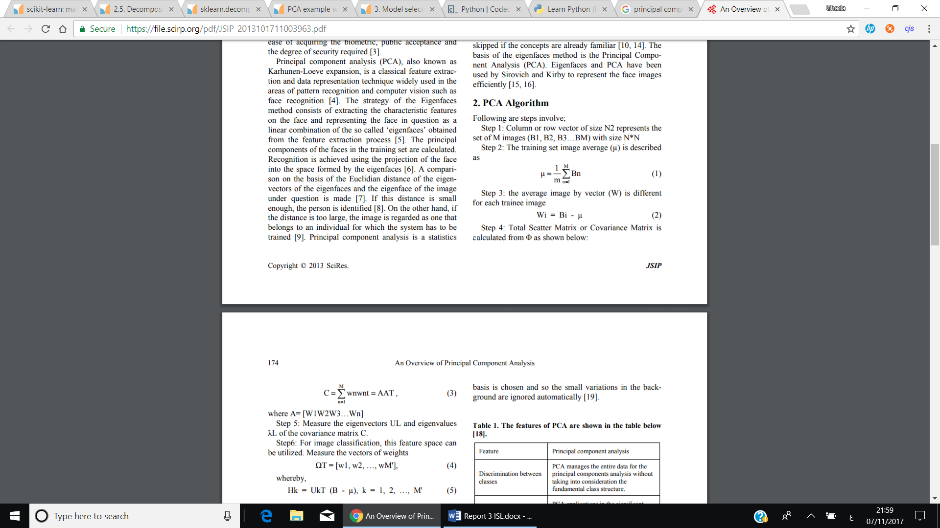



* 1. Scaling the variables.

Before performing PCA on observations, all data, should be scaled (using a certain method, such as standard deviation = 1).

It is important since; different variables are measured in different units, so when calculating the **variance** of each variable, it will result in first principal component loading vector to be for example, large loading, since it had the largest variance. Mostly, each variable is scaled to have unit standard deviation when the possibility of them having different units is high. Hence, scaling has a substantial impact on obtained results, and should be performed beforehand.

* 1. The minimum number of Principal Components to use is calculated via, **min(n-1, p),** where n is the number of observations and p is the number of variables. However, it is crucial that we use the very first PC’s to help in visualising data. By examining a **SCREE PLOT …**
  + Clustering:

Clustering can be viewed as the set of algorithms, which used in order to find similar subgroups within dataset. Each cluster, contains number of observations in which they’re found similar to each other, whereas observations in other groups are found dissimilar. A partitioning rule, is used to determine what observations can be included at an exact cluster, in other words, what it means for two items to be similar or different.

Nonetheless, Clustering is unsupervised dilemma(problem), because it’s applied to determine different clusters, in a set of unlabelled data.

(<https://home.deib.polimi.it/matteucc/Clustering/tutorial_html/>)

There are quite a few requirements that each clustering algorithm, should satisfy, such as, ability to deal with noise and outliers, high dimensionality, insensitivity to order of data provided and scalability.

Some of issues faced when using clustering include, the difficulty in specifying a distance measurement, which is used to indicate the partition between clusters. Time complexity is also considered, since datasets have high dimensionality, and the results of clustering algorithms can be viewed in different ways.

However, since every clustering type follows a different set of rules for determining the similarity measure between points. It’ll be mentioned, 3 of the most popular algorithms used, which are, K-means, Hierarchal and Density-based Algorithms.

(include a bit on the differen types of algorithms? )

* **K-Means Clustering:**

This algorithm uses a set value of K, which specifies the number of distinct clusters dataset should divided to. Choosing value of K is significant, since the algorithm assign each observation to only one of K-clusters.

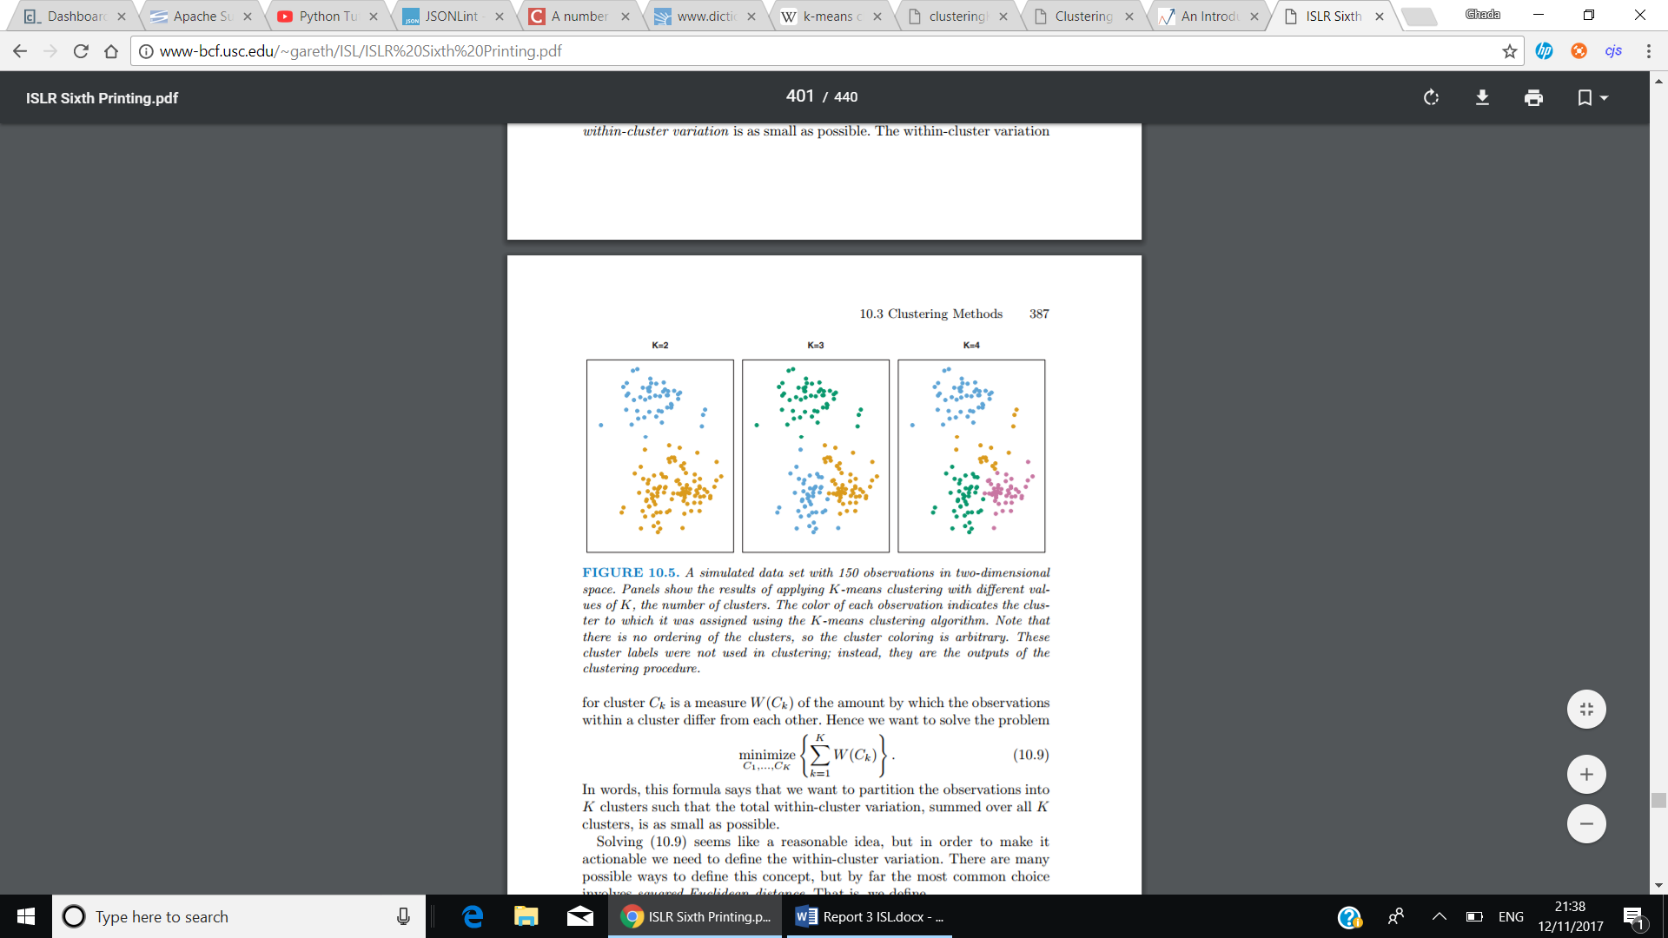

Moreover, K-means successfully achieve two main conditions, that are, each data point should belong to 1 cluster, and there is no overlapping found in clusters.

An important point that should be as well considered is, minimizing the within-cluster variation. The within-cluster variation, measures how tightly grouped the clusters are and can in fact be determined using several options, such as, Euclidian’s distance … etc.

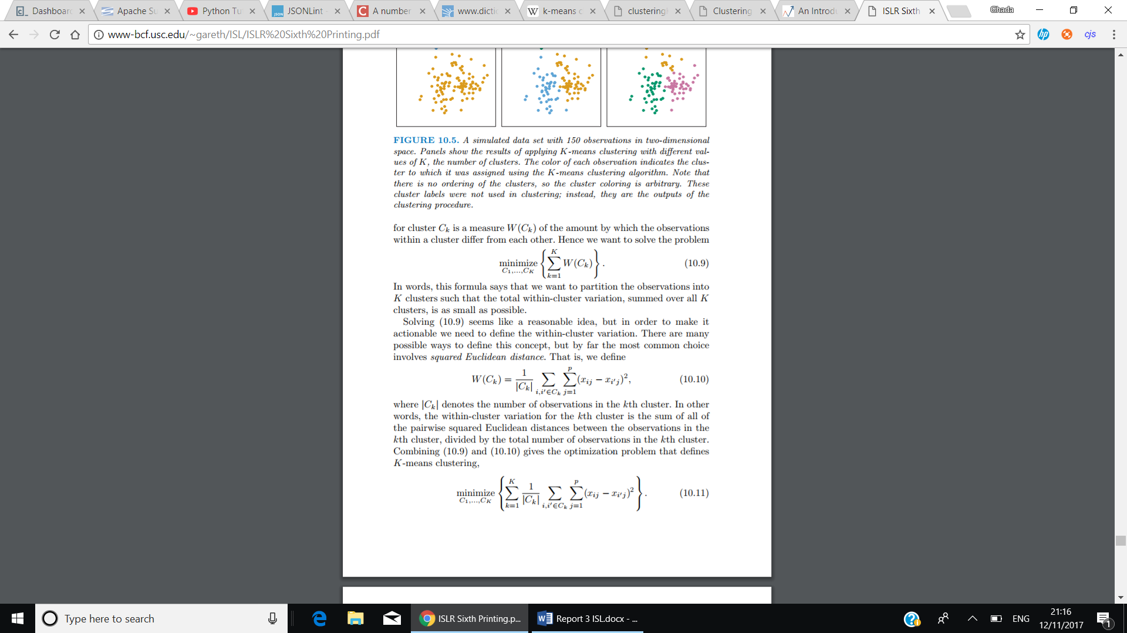

The above method, describes the optimisation problem which defines k-means clustering. The within-cluster variation of the kth cluster can be described as, the sum of all pairwise squared Euclidean distances between data points in the kth cluster, divided by |Ck| the number of data points in the kth cluster.

An abstract way to describe K-means clustering algorithms, used from ISLR book, is as follows:

1. For each observation in dataset, assign a random number from 1 to K.
2. Iterate until clusters, stop changing.
   1. For each cluster K, compute cluster centroid.
   2. Allocate each observation to the cluster, that has the nearest centroid.

Centroid, is the mean of observations assigned to each cluster.

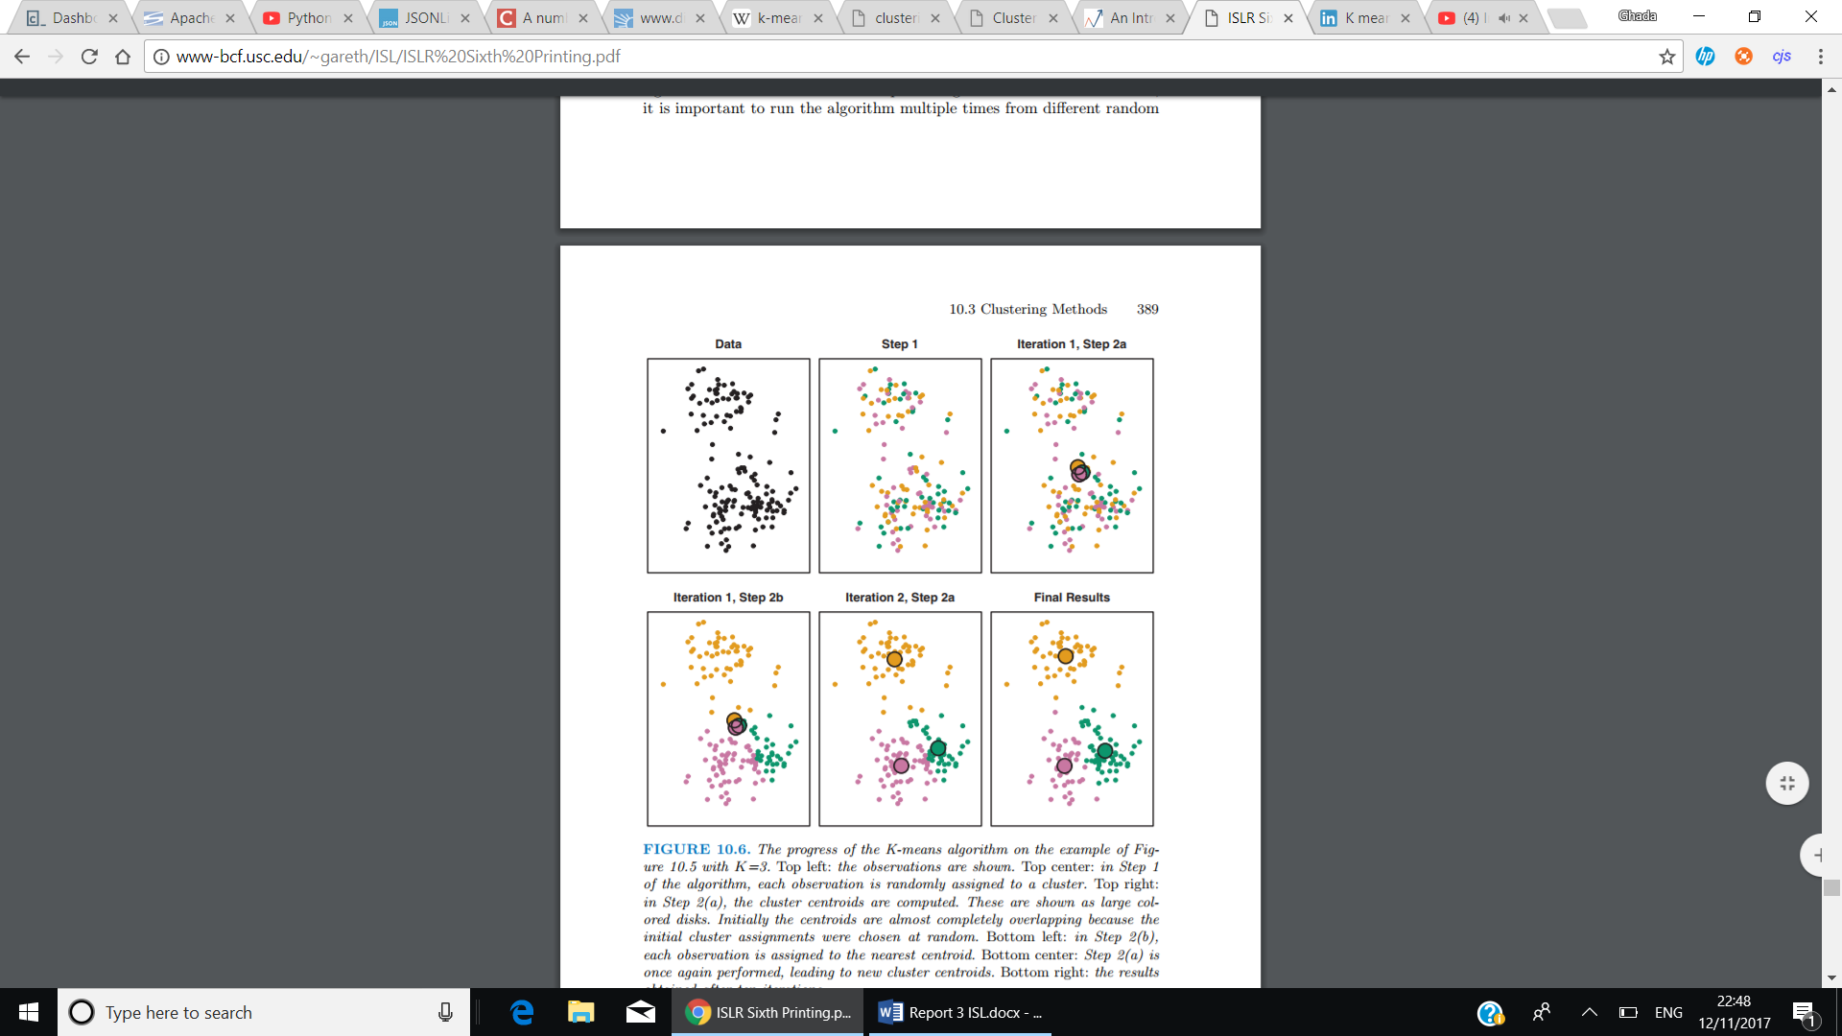

There are several difficulties encountered when using K-means, which include, choosing the value of K (number of clusters) beforehand, portioning data into K clusters while keeping the within-cluster variation minimized, since there are Kn different ways to portion data. However, using K-means is found to be efficient with datasets of high dimensionality, and considered to be easy to implement, and has high performance.

* **Hierarchal clustering:**

Another algorithm that doesn’t require the user to specify the number of clusters beforehand. Instead it creates a tree-based representation of data observations (builds hierarchy of clusters), which is known as *dendrogram*. It has two types, Agglomerative, and Divisive.

Agglomerative, which is known as “bottom-up, the way it works is that each observation initiates in its own cluster, and merging pairs of clusters as moving upwards (the top). Whereas, Divisive “top-down”, all clusters are in the same cluster, and it starts splitting them up, while moving down the hierarchy.

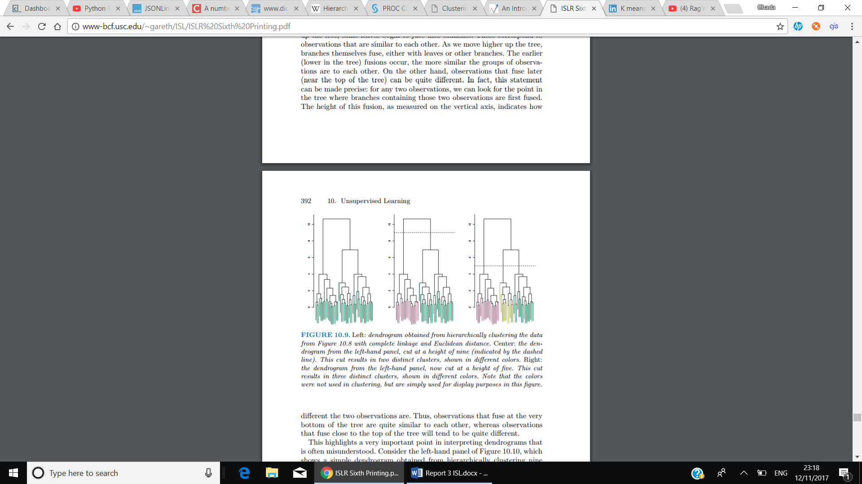

The height in the dendrogram at which two clusters are merged represents the distance between two clusters in the data space.

* + Dissimilarity measure
  + Linkage

Advantage?

Disadvantage?

Comparsion between K-means and herarichal?

* **Density-Based(DBSCAN) Clustering:**

Explain?

Advantage?

Disadvantage?

Why Machine Learning?

Due to the significant growth of malware on devices in general, antimalware programs are trying to keep up to date with changes made. Some Antimalware are built to compare signatures to the database, to decide whether a code is considered benign or malicious, this method is now becoming less helpful with time. Using machine learning algorithms to better detect malicious code, as it has some traits that helps in deciding. “So, code that’s determined to be benign might have some traits that the software considers to be a possible indication of malware.”

Machine learning, assist devices to learn new things about data give, without the need of explicitly programming it.

For example, AI-Squared analyses large amounts of data and uses a recurrent neural network and machine learning techniques (also known as unsupervised learning) to find anomalies. Once something abnormal is found, a human analyst is then alerted to confirm whether the activity is a hacker or a genuine user. After the intent of the activity is decided, artificial intelligence takes these findings and puts them into the equation for future reference. This security process is called supervised learning.

<https://www.ccsinet.com/blog/what-to-expect-from-ai-and-cyber-security-roles-in-the-future/>

The only things that unsupervised learning methods have to work with are the observed input patterns xi, which are often assumed to be independent samples from an underlying unknown probability distribution PI [x], and some explicit or implicit a priori information as to what is important. One key notion is that input, such as the image of 1 a scene, has distal independent causes, such as objects at given locations illuminated by particular lighting. Since it is on those independent causes that we normally must act, the best representation for an input is in their terms. Two classes of method have been suggested for unsupervised learning. Density estimation techniques explicitly build statistical models (such as BAYESIAN NETWORKS) of how underlying causes could create the input. Feature extraction techniques try to extract statistical regularities (or sometimes irregularities) directly from the inputs. Unsupervised learning in general has a long and

<http://www.gatsby.ucl.ac.uk/~dayan/papers/dun99b.pdf>